**VISVESVARAYA TECHNOLOGICAL UNIVERSITY**

**“JnanaSangama”, Belgaum -590014, Karnataka.**



**PROJECT WORK-1 REPORT**

**on**

**BAKERY SHOP**

***Submitted by***

***SUDESHNA BHUSHAN* (1BM19CS189)**

***DYUTHI ABHITHA PRAKASH* (1BM19CS196)**

***NANDITA MAHENDRA* (1BM19CS203)**

***RUBIANA JOSEPHINE PAUL* (1BM19CS208)**

***Under the Guidance of***

|  |  |
| --- | --- |
| **REKHA G S**  **Assistant Professor, BMSCE** |  |

***in partial fulfillment for the award of the degree of***

**BACHELOR OF ENGINEERING**

***in***

**COMPUTER SCIENCE AND ENGINEERING**



**B.M.S. COLLEGE OF ENGINEERING**

**(Autonomous Institution under VTU)**

**BENGALURU-560019**

**Sep-2020 to Jan-2021**

**B. M. S. College of Engineering,**

**Bull Temple Road, Bangalore 560019**

(Affiliated To Visvesvaraya Technological University, Belgaum)

**Department of Computer Science and Engineering**



**CERTIFICATE**

This is to certify that the project work entitled “**BAKERY SHOP**” carried out by **SUDESHNA BHUSHAN(1BM19CS189),DYUTHI ABHITHA PRAKASH (1BM19CS196), NANDITA MAHENDRA(1BM19CS203) AND RUBIANA JOSEPHINE PAUL (1BM19CS208)** who are bonafide students of **B. M. S. College of Engineering.** It is in partial fulfillment for the award of **Bachelor of Engineering in Computer Science and Engineering** of the Visveswaraiah Technological University, Belgaum during the year 2020-2021. The project report has been approved as it satisfies the academic requirements in respect of **Project Work-1 (19CS3PWPW1)**work prescribed for the said degree.

Signature of the Guide                 Signature of the HOD

REKHA G S Dr. Umadevi V

Assistant Professor Associate Prof.& Head, Dept. of CSE

BMSCE, Bengaluru BMSCE, Bengaluru

External Viva

Name of the Examiner                                                                                       Signature with date

1._____________________________ ________________________

2. _____________________________ _________________________

**B.M.S. College of EngineerinG**

**DEPARTMENT OF COMPUTER SCIENCE AND ENGINEERING**



***DECLARATION***

We, **SUDESHNA BHUSHAN(1BM19CS189),DYUTHI ABHITHA PRAKASH (1BM19CS196), NANDITA MAHENDRA(1BM19CS203) AND RUBIANA JOSEPHINE PAUL (1BM19CS208)**, students of 3rd Semester, B.E, Department of Computer Science and Engineering, B. M. S. College of Engineering, Bangalore, hereby declare that, this Project Work-1 entitled "Project Title" has been carried out by us under the guidance of **REKHA G S**, Assistant Professor, Department of CSE, B. M. S. College of Engineering, Bangalore during the academic semester Sep-2020-Jan-2021

We also declare that to the best of our knowledge and belief, the development reported here is not from part of any other report by any other students.

Signature

**SUDESHNA BHUSHAN (1BM19CS189)**

**DYUTHI ABHITHA PRAKASH (1BM19CS196)**

**NANDITA MAHENDRA (1BM19CS203)**

**RUBIANA JOSEPHINE PAUL (1BM19CS208)**

1. **INTRODUCTION**

**Website Development for “BAKERY SHOP”.**

**This website supports all the users who visits this**

**webpage.**

**People can also visit our blogs.**

**People who sign in for the page and subscribe for the**

**newsletter receives updates regularly from our shop.**

**Regular updates of shop will be sent to mobile and**

**through mail.**

1. Design Layouts: Handwritten Screen Shots of Webpages

2.1: Customer Information Multi-Step-form with dark mode

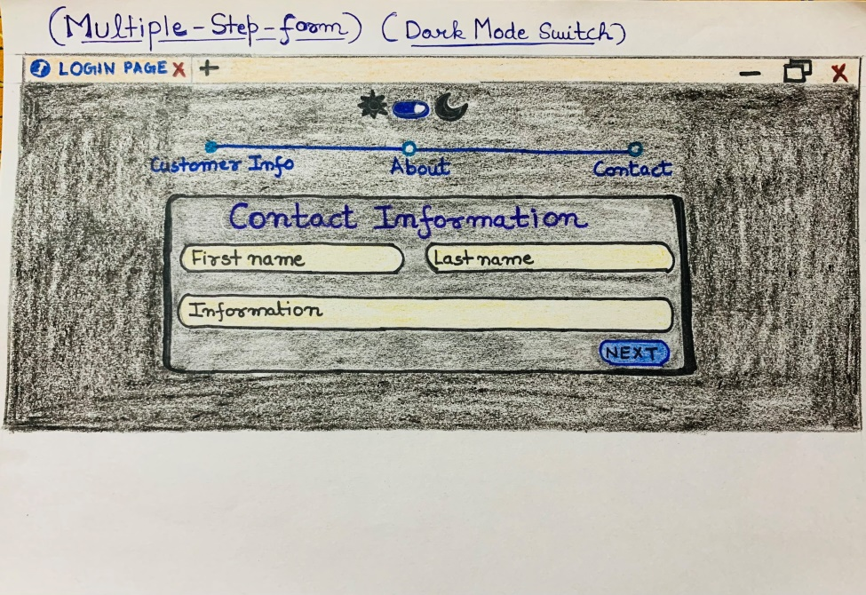

**2.2: Locate us webpage of the shop**

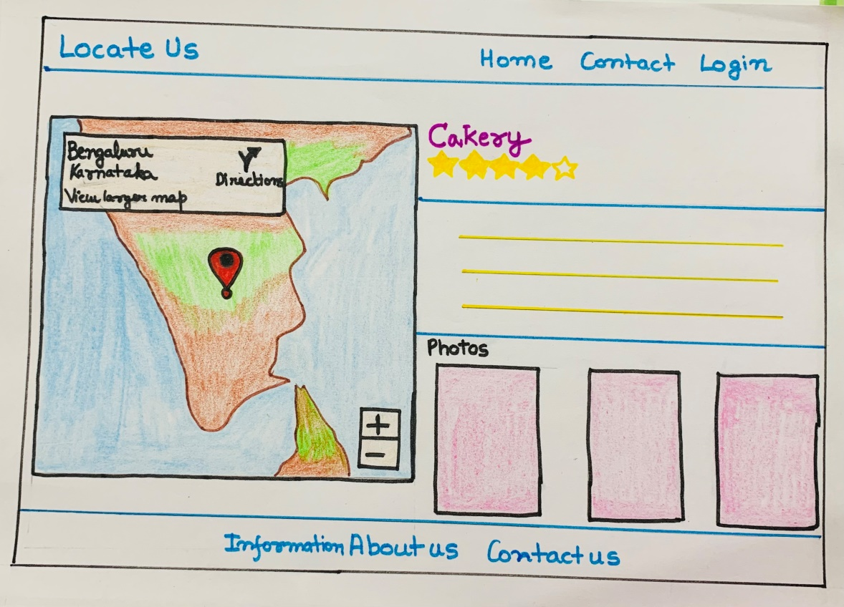

**2.3: Home Page of the shop**

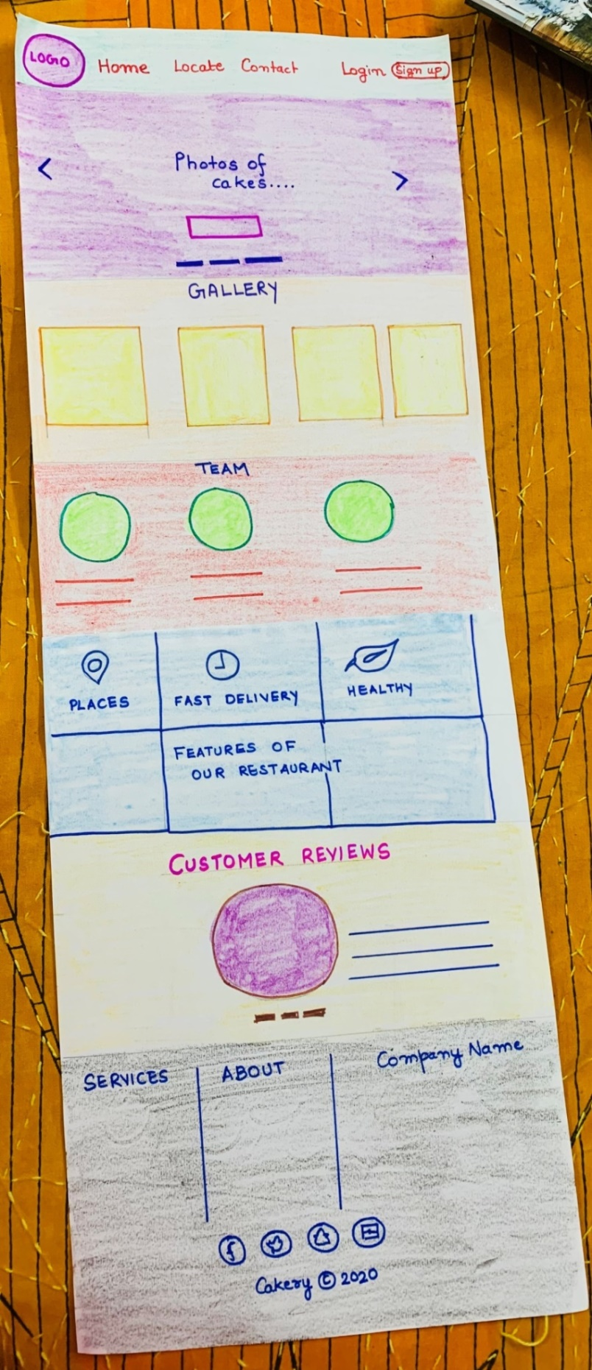

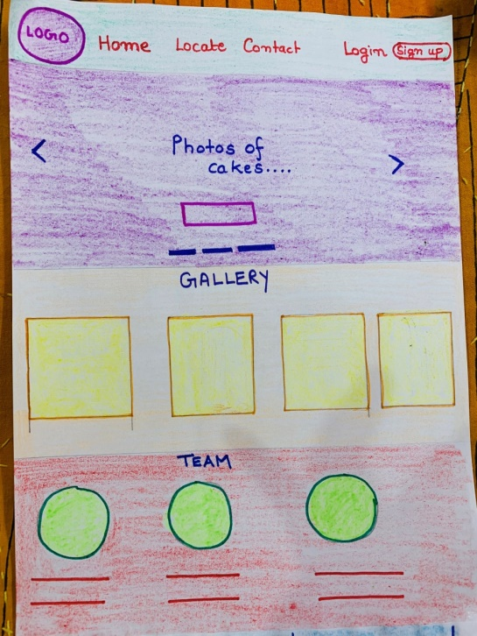

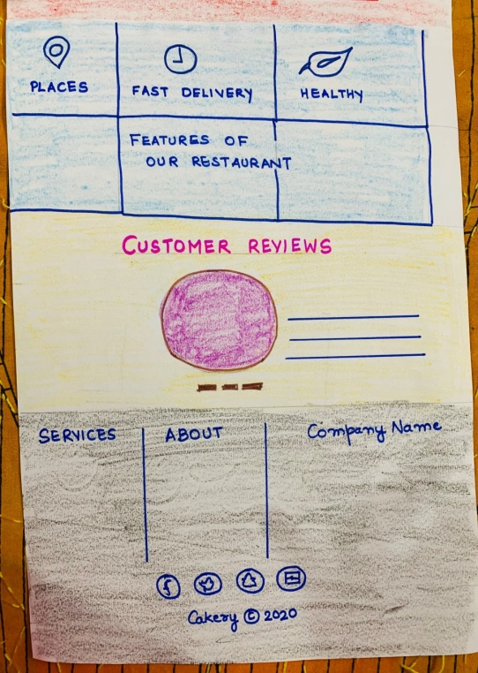

**2.4: Contact Us page of the shop**



